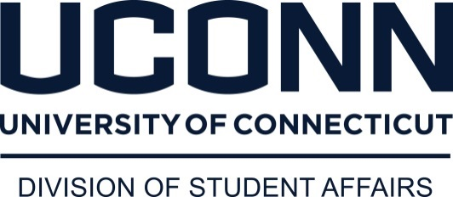
Department of Dining Services
Dear Parent or Guardian:

I recently received communication that your child will be attending UConn Pre-College Summer and has a food allergy or specific dietary concerns. Below is a link to the Department of Dining Service’s website that will connect you our nutrition webpage. One week before the camp begins, select Putnam Dining Hall as the dining unit because your child will be dining there. As an example you may select “Putnam” to view menus. Once you have opened the site, select SET FILTERS (upper right hand corner of the page). Check “does not contain” and select the appropriate allergen. This will help you see the specific hot line menu for Putnam during the camp MINUS the allergens. This does not show our complete salad bar and other standard options such as cereals, bagels, beverages, etc. One important thing to note is that during the summer camp months Dining Services will not have any recipes that contain peanuts or tree nuts. You should also view “Everyday Items”, which can be found on the same page where you selected McMahon Dining Hall. This will show you many of the items typically found in the dining hall beyond our entrée’s and side dishes.

http://dining.uconn.edu/nutrition/

These hot items will all be clearly marked with a nutrition analysis card that contains the allergen information directly on the serving line. Please know our management staff is willing to answer any questions you may have. Please ask to speak to a manager if there are ANY questions about salad bar items, specific recipes or method of preparation. Because this is a self-serve buffet, if you have cross contamination concerns, we are happy to plate the meal in the back of the house. Please ask a manager if there are allergies to items NOT identified in the allergen list such as seeds, mushrooms, fin fish, tomatoes, etc.

A note of caution to avoid all items made in our commissary bakery for both gluten and nut allergies. I certainly hope this is helpful information. Please direct any questions to the management team when you arrive. Our goal is to help your child enjoy their dining experience here at UCONN! Please let me know if you have any questions.

Thank you,

Michael White
Executive Director
3384 Towers Loop Road-Wade Building
U-4071
Storrs, CT 06269
860-486-3128

